EXPERIMENT:1
DDL Commands – CREATE, ALTER, DROP, RENAME, TRUNCATE
AIM:
To create a database and employee table, and perform DDL (Data Definition Language) commands such as CREATE, ALTER, RENAME, TRUNCATE, and DROP.
PROCEDURE:
- Create a new database named company.
- Select the company database for use.
- Create a table named employee with the required fields.
- Display the table structure using the DESC command.
- Alter the table by adding a primary key.
- Add a new column to the table.
- Modify the size of an existing column.
- Drop the newly added column.
- Rename the table.
- Display the renamed table structure.
- Rename the table back to its original name.
- Remove all records using the TRUNCATE command.
Delete the table using the DROP command.
PROGRAM:
Step 1: Create Database
CREATE DATABASE company;

Step 2: Select Database
USE company;

Step 3: Create Table
CREATE TABLE employee
(
Worker_ID INT,
Name VARCHAR(30),
Department VARCHAR(30),
Salary INT,
Phone BIGINT,
Department_Manager VARCHAR(30)
);

Step 4: Display Table Structure
DESC employee;

Step 5: Add Primary Key
ALTER TABLE employee
ADD PRIMARY KEY (Worker_ID);

Step 6: Add New Column
ALTER TABLE employee
ADD Email VARCHAR(50);

Step 7: Modify Column
ALTER TABLE employee
MODIFY Name VARCHAR(50);

Step 8: Drop Column
ALTER TABLE employee
DROP COLUMN Email;

Step 9: Rename Table
ALTER TABLE employee
RENAME TO worker;

Step 10: Display Table Structure
DESC worker;

Step 11: Rename Back
ALTER TABLE worker
RENAME TO employee;

Step 12: Truncate Table
TRUNCATE TABLE employee;

Step 13: Drop Table
DROP TABLE employee;
OUTPUT:
1. CREATE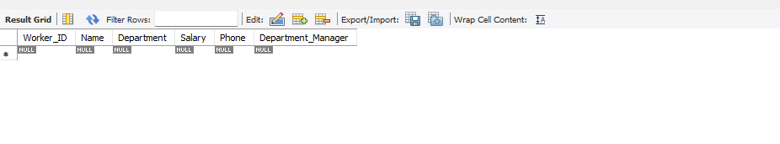

2.ALTER
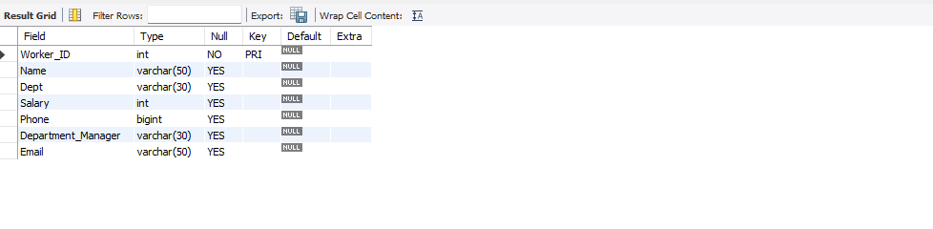

3.DROP
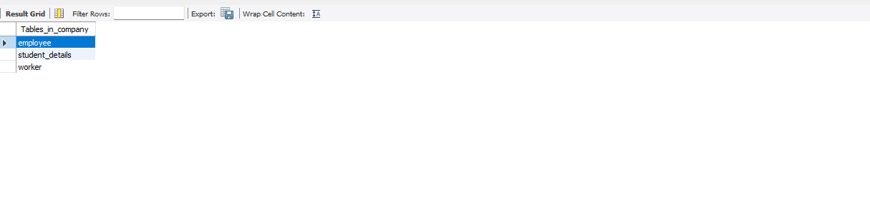

4.RENAME
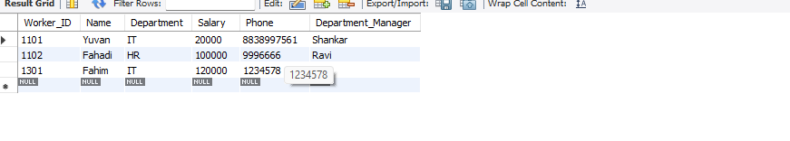
5.TRUNCATE:
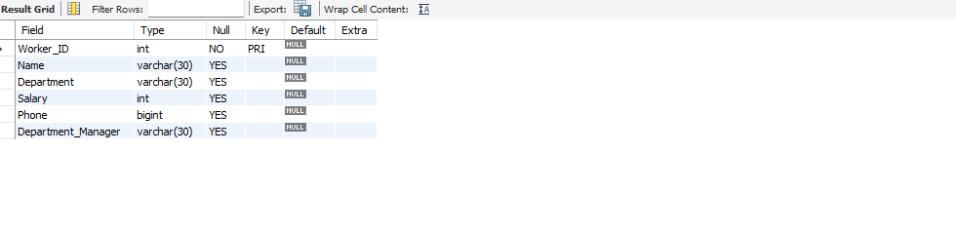

RESULT:
Thus, the DDL commands CREATE, ALTER, DROP, RENAME, and TRUNCATE were executed successfully
EXPIREMENT 2:
Implementation of Integrity Constraints (PRIMARY KEY, FOREIGN KEY, UNIQUE, CHECK, NOT NULL)
AIM:
To create tables using various integrity constraints such as PRIMARY KEY, FOREIGN KEY, UNIQUE, CHECK, and NOT NULL.
PROCEDURE:
- Create a database named company.
- Select the company database.
- Create a Department table with a primary key.
- Create an Employee table.
- Apply the PRIMARY KEY constraint on Worker_ID.
- Apply the FOREIGN KEY constraint on Department_ID.
- Apply the UNIQUE constraint on Phone.
- Apply the NOT NULL constraint on Name.
- Apply the CHECK constraint on Salary.
- Insert records into both tables.
Display the records.
PROGRAM:
Step 1: Create Database
CREATE DATABASE company;

Step 2: Select Database
USE company;

Step 3: Create Department Table
CREATE TABLE department
(
Department_ID INT PRIMARY KEY,
Department_Name VARCHAR(30) NOT NULL
);

Step 4: Insert Values into Department Table
INSERT INTO department VALUES
(101,'IT'),
(102,'HR'),
(103,'Software Developer'),
(104,'Software Engineering');

Step 5: Display Department Table
SELECT * FROM department;

Step 6: Create Employee Table with Constraints
CREATE TABLE employee
(
Worker_ID INT PRIMARY KEY,
Name VARCHAR(50) NOT NULL,
Department_ID INT,
Salary INT CHECK (Salary > 0),
Phone BIGINT UNIQUE,
Department_Manager VARCHAR(30),
FOREIGN KEY (Department_ID)
REFERENCES department(Department_ID)
);

Step 7: Describe Employee Table
DESC employee;

Step 8: Insert Values into Employee Table
INSERT INTO employee VALUES
(1101,'Yuvan',101,20000,8838997561,'Shankar'),
(1102,'Fahadi',102,100000,9996666,'Ravi'),
(1301,'Fahim',101,120000,1234578,'Ravi'),
(1405,'Santhosh',103,150000,1987654,'Ravi'),
(1501,'Shankar',102,20000,6584231,'Shankar'),
(1705,'Dharun',103,100000,75816452,'Abban'),
(1835,'Akash',101,120000,8561457,'Udhay'),
(1295,'Udhay',102,120000,657564823,'Rithesh'),
(1125,'Dhanush',104,100000,1372941,'Udhay'),
(1055,'Harifaran',101,5000,9814521,'Ravi');

Step 9: Display Employee Table
SELECT * FROM employee;

Step 10: Verify PRIMARY KEY Constraint
INSERT INTO employee
VALUES
(1101,'Kumar',101,30000,9876543210,'Ravi');
Output: Duplicate entry for Worker_ID (PRIMARY KEY violation).

Step 11: Verify UNIQUE Constraint
INSERT INTO employee
VALUES
(1200,'Arun',101,25000,8838997561,'Ravi');
Output: Duplicate entry for Phone (UNIQUE constraint violation).

Step 12: Verify CHECK Constraint
INSERT INTO employee
VALUES
(1201,'Bala',101,-5000,9876541230,'Ravi');
Output: CHECK constraint violated (Salary > 0).

Step 13: Verify NOT NULL Constraint
INSERT INTO employee
VALUES
(1202,NULL,101,25000,9876545678,'Ravi');
Output: Column Name cannot be NULL.

OUTPUT:
1.PRIMARY KEY
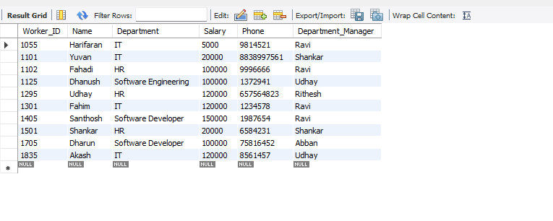

2.FORIEGN KEY
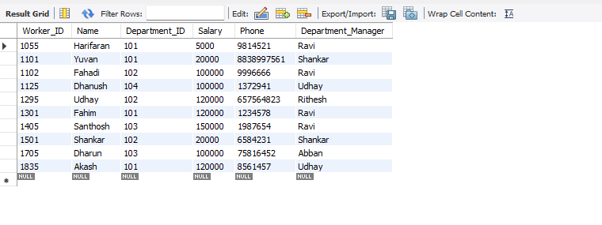

3.UNIQUE KEY
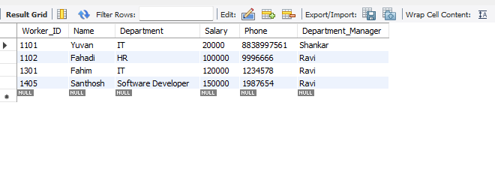
RESULT:

Thus, the integrity constraints namely PRIMARY KEY, FOREIGN KEY, UNIQUE KEY, NOT NULL, and CHECK were implemented successfully on the employee table in the company database, and the expected results were obtained.

EXPIREMENT 3:
DML Commands – INSERT, SELECT
AIM:
To perform DML (Data Manipulation Language) commands such as INSERT and SELECT on the employee table.
PROCEDURE:
Create the employee table in the company database.
- Insert employee records into the table using the INSERT command.
- Display all the records using the SELECT command.
- Modify the salary of an employee using the UPDATE command.
- Display the updated records using the SELECT command.
- Delete a specific employee record using the DELETE command.
- Display the remaining records using the SELECT command.
Verify that the DML operations have been executed successfully.
PROGRAM:

Step 1: Select the Database
USE company;
Explanation:
This command selects the company database so that all operations are performed on it.

Step 2: Create Employee Table
CREATE TABLE employee
(
Worker_ID INT PRIMARY KEY,
Name VARCHAR(50),
Department VARCHAR(30),
Salary INT,
Phone BIGINT,
Department_Manager VARCHAR(30)
);
Explanation:
This command creates the employee table with six columns.

Step 3: Insert Records
INSERT INTO employee VALUES
(1101,'Yuvan','IT',20000,8838997561,'Shankar'),
(1102,'Fahadi','HR',100000,9996666,'Ravi'),
(1301,'Fahim','IT',120000,1234578,'Ravi'),
(1405,'Santhosh','Software Developer',150000,1987654,'Ravi'),
(1501,'Shankar','HR',20000,6584231,'Shankar');
Explanation:
This command inserts five employee records into the table.

Step 4: Display All Records
SELECT * FROM employee;
Explanation:
This command displays all records stored in the employee table.

Step 5: Update Employee Salary
UPDATE employee
SET Salary = 30000
WHERE Worker_ID = 1101;
Explanation:
This command updates the salary of employee 1101 to 30000.

Step 6: Display Updated Record
SELECT * FROM employee;
Explanation:
This command displays the updated employee details.

Step 7: Delete a Record
DELETE FROM employee
WHERE Worker_ID = 1501;
Explanation:
This command deletes the employee whose Worker_ID is 1501.

Step 8: Display Remaining Records
SELECT * FROM employee;
Explanation:
This command displays the remaining records after deletion.
OUTPUT:

1.SELECT:
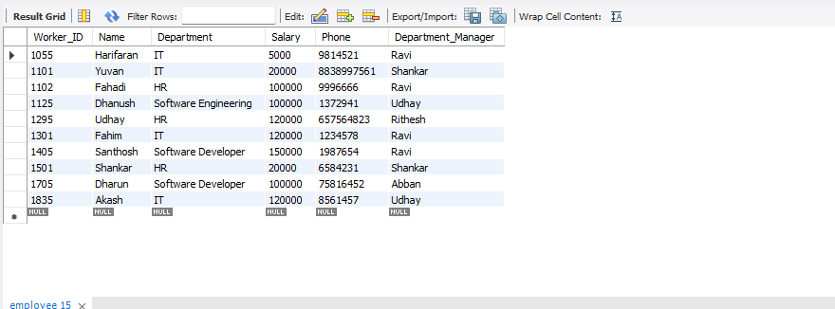
2.INSERT:
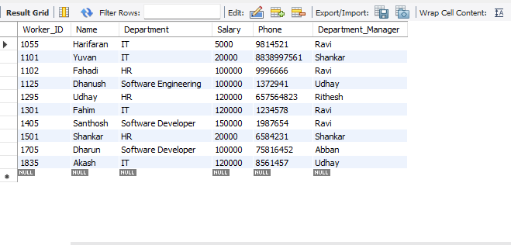

RESULT:
Thus, the DML commands namely INSERT,SELECT were executed successfully on the employee table in the company database, and the expected results were obtained.

